Framework should be changed to System



Federal Republic of Nigeria



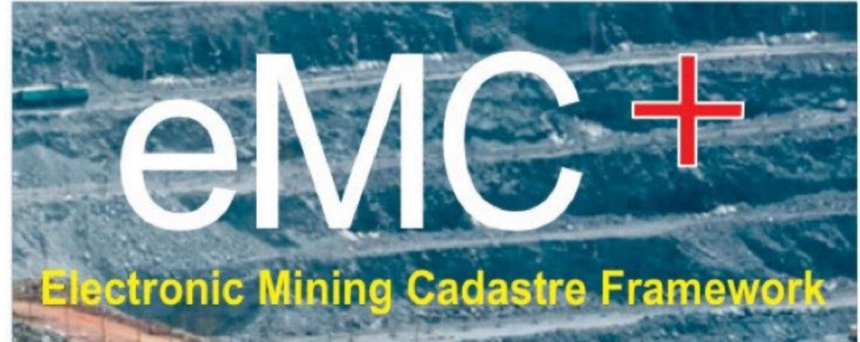

TRANSPARENCY I COMPLIANCE I EFFICIENCY

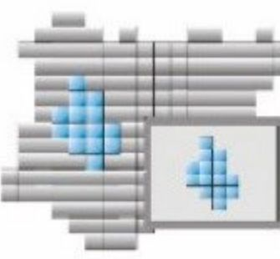

NIGERIA

MINING CADASTRE OFFICE

Framework should be changed to System

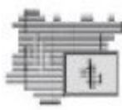



Federal Republic of Nigeria

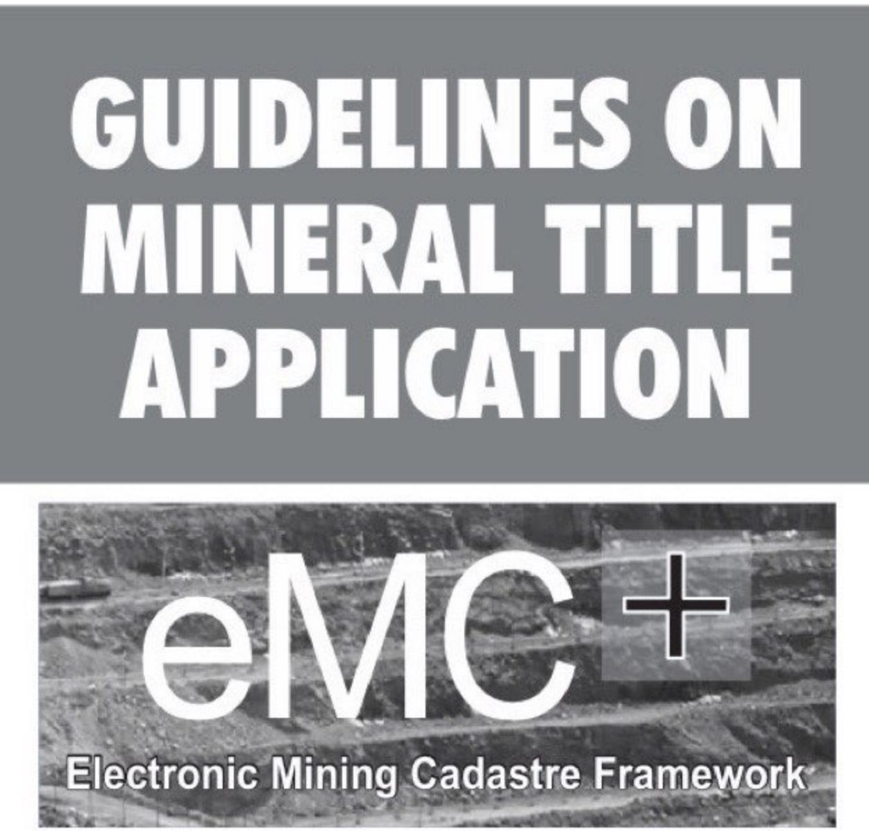

TRANSPARENCY I COMPLIANCE I EFFICIENCY

NIGERIA

MINING CADASTRE OFFIC E

Contact:

**Director-General**

**Nigeria Mining Cadastre Office**

No.37, Lobito Crescent,

off Adetokunbo Ademola Crescent,

P.M.B.107,Wusell,Abuja,Nigeria

Phone:+234 816 410 1937

Email:info@miningcadastre.gov.ng

Website:miningcadastre.gov.ng

©2021

NIGERIA

MINING CADASTRE OFFIC E

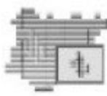

**1.0 INTRODUCTION**

**1.1 Establishment, Mandate and Functions of the Mining Cadastre Office**

The Nigeria Mining Cadastre Office (MCO) was established in 2007 with the responsibility for the Administration and Management of Mineral Titles in Nigeria in accordance with Section 5 (1) of the Nigerian Minerals and Mining Act, 2007 (the Act). The MCO, in addition to any other functions prescribed by or under the Act and the Nigerian Minerals and Mining Regulations, 2011 (the Regulations), performs the following:

i Consider applications for mineral titles and permits, issue, suspend and upon written approval of the Minister, revoke any mineral title;

ii. Receive and dispose of applications for modifications (renewal, transfer, relinquishment, consolidation, extension of areas etc.) of mineral titles;

iii. Maintain a chronological record of all applications for mineral titles in a Priority Register, which is used specifically to ascertain the priority and registration of applications for exclusive rights on free areas;

iv. Maintain a general register, which is used for all other types of applications where registration of the priority is not required; and

NIGERIA

MINING CADASTRE OFFIC E

The operations of the eMC+ is based on internationally accepted principles and rules for the administration and management of Mineral Titles. These include the following:

1. Conducive macro-economic environment for mining investment
2. Clear, stable, legal, and regulatory frameworks
3. Well-defined institutional responsibilities
4. Transparent and non-discretionary procedures
5. Stable, competitive, and fair fiscal regimes
6. Priority based on First Come First Serve
7. Use it or lose it
8. Security of title

NIGERIA

MINING CADASTRE OFFIC E 2

V. Undertake such other activities reasonably necessary for the purpose of carrying out its duties and responsibilities under the provisions of the Act, and the Regulations.

**1.2 Electronic Mining Cadastre Plus (eMC+)**

In furthering its objective to provide an independent, efficient, transparent, modern Mining Cadastre System, which grants and administers mining licences and permits in accordance with the provisions of the Act and the Regulations and consistent with best international practices; the Nigeria MCO has been upgraded and automated to an electronic Mining Cadastre Plus (eMC+) system. As part of the upgrade, the MCO has established Zonal Office in each of the six (6) Geopolitical Zones of the Country.

The main functionality of the eMC+ enables fast and seamless online preparation, submission, processing, recording, monitoring of procedures and granting of Mineral Titles in Nigeria.

**1.3 Rules and Operational Principles of the eMC+**

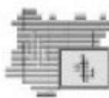

**2.0 TYPES OF MINERAL TITLES**

In line with Section 46 of the Act, the right to search for, or exploit Mineral Resources in Nigeria, is obtained through one of the following mineral titles:

a) Reconnaissance Permit (RP)

b) Exploration Licence (EL)

c) Mining Lease (ML)

d) Quarry Lease (QLS)

e) Small Scale Mining Lease (SSML)

f) Water Use Permit (WUP)

**2.1 Reconnaissance Permit**

Sections 47, 57 and 58 of the Act and sections 32, 33, and 34 of the Regulations, prescribe that:

a) the MCO shall within 30 days of the receipt of an application from any qualified applicant and upon the payment of the prescribed fees, grant and issue a Reconnaissance Permit to the applicant to search for minerals.



NIGERIA

MINING CADASTRE OFFIC E 3_

b) The Permit enables the holder to carry out reconnaissance activities on a non-exclusive basis.

c) The holder of the Permit is not to engage in drilling, excavation or other sub-surface techniques, and must conduct activities in an environmentally and socially responsible manner and compensate for any damage to crops or property in the course of prospecting.

d) The Permit is issued for one year and it is not transferable, but renewable annually.

**2.2 Exploration Licence**

Sections 48, 59, and 62 of the Act, and Sections 35, 36, 37, 38, 39 and 40 of the Regulations provide that:

a) The MCO, on receipt of a valid application, is obliged to grant and issue an Exploration Licence within 30 days to the applicant.

b) A Licence shall not be granted over any land that is subject of an existing Exploration Licence, Mining Lease, Small-Scale Mining Lease, Quarry Lease, Protected/Restricted area or areas closed to prospecting/mining activities (e.g., forest reserves, military areas, Government development areas, national heritage areas, towns, cities etc.

c) The duration of an Exploration Licence is three (3) years, and renewable for a further period of two (2) terms of two years each, provided that the title holder has complied with the minimum work commitment/programme and all other legal requirements.



NIGERIA

MINING CADASTRE OFFIC E 4

d) The area of land covered by an Exploration Licence shall not exceed 200 km2 (1000 CUs).

**2.3 Mining Lease**

Sections 50, 65, 66 and 67 of the Act, and Sections 56, 57, 58, 59,60,61 and 62 of the Regulations, stipulate that:

a) The MCO, upon receipt of a valid application shall, grant and issue a Mining Lease within 45 days of the application to the applicant.

b) The duration of a Mining Lease is 25 years, renewable every 24 years, provided that the holder has complied with the minimum work programme and all other legal and regulatory requirements.

c) The Lease area shall be determined in relation to the ore body as defined in the feasibility study, in addition to an area reasonably required for the working of the deposit, not exceeding 50 km2(250 CUs).

**2.4 Quarry Lease**

Sections 51, 77 and 79 of the Act and Sections 67, 68, 69, 70, 71 and 72 of the Regulations, stipulate that:

a) The MCO, upon receipt of a valid application, shall grant and issue to the applicant a Quarry Lease within 45 days.

b) The duration of a Quarry Lease shall not exceed five (5) years and may be renewed every five years as required, provided that the renewal application is made three (3) months before the expiration of the Lease.



NIGERIA

MINING CADASTRE OFFIC E 5_

c) The area of land for a Quarry Lease shall not exceed 5km2 (25CUs).

**2.5 Small-Scale Mining Lease**

Sections 49 and 90 of the Act and Sections 45, 46, 47, 49, 50 and 51 of the Regulations prescribe that:

a) The MCO, upon receipt of a valid application, shall grant and issue a Small-Scale-Mining Lease within 45 days to the applicant. A SSML shall not be granted in respect of any area within an Exploration Licence, Mining Lease or Quarry Lease to any person except the holder of an Exploration Licence, Quarry Lease or Mining Lease covering the area.

b) The duration of a SSML is five (5) years and is renewable for further periods of five years provided that the minimum work obligations have been fulfilled. The area of land for a SSML shall not exceed 3 km2.

c) When the level of operations of a SSML exceeds any of the criteria established in the definition of a SSML, the holder shall convert such a Lease into a Mining Lease by applying to the MCO.

**2.6 Water Use Permit**

Section 52 of the Act, and Sections 77, 78, 79, 80, and 81 of the Regulations, prescribe that:

a) The area of land in respect of which any Water Use Permit is granted shall not exceed the area reasonably required for the purpose of the Permit as defined in the Regulations.



NIGERIA

MINING CADASTRE OFFIC E. 6_

b) A WUP will remain in force as long as the Mining Lease, Quarry Lease or SSML, for which the WUP was granted remains valid.

c) The Permit is issued only for mining purposes.

|  |  |  |  |  |  |
| --- | --- | --- | --- | --- | --- |
| S/NO | TYPES OF LICENSES | MAXIMUM SIZE | MAXIMUM NUMBER OF CADASTRAL UNIT (CUs) | DURATION | PROCESSING TIME |
| 1 | Reconnaissance Permit (RP) | Non-  Exclusive | Non-  Exclusive | 1 YEAR  (Renewable  annually) | Not later than 30 days of filing application |
| 2 | Exploration License (EL) | 200KM2 | 1000 (20,000 Ha) | 3 YEARS  (Renewable twice for 2 years each) | Not later  than 30 days of filing  application |
| 3 | Small-Scale Mining Lease  (SSML) | 3KM2 | 15 (300 Ha) | 5 YEARS  (Renewable for further period of 5  years) | Not later than 45 days  of filling application |
| 4 | Mining Lease (ML) | 50KM2 | 250 (5,000 Ha) | 25 YEARS  (Renewable every 24 years) | Not later than 45 days  of filling application |
| 5 | Quarry Lease (QLS) | 5KM2 | 25 (500 Ha) | 5 YEARS  (Renewable  as often as  required) | Not later than 45  days of filling  application |
| 6 | Water Use Permit (WUP) |  |  | Same with the  duration of Lease | Not later than 30 days  of filing application |

NIGERIA

MINING CADASTRE OFFIC E 7

3.0. REQUIREMENTS FOR APPLICATION OF MINERAL TITLES

The requirements for the grant of the different types of Mineral Titles as stated below.

**3.1 Mining Lease**

Pre-grant requirements:

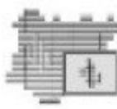

i. Duly completed application forms in triplicate copies

ii. Feasibility report (with Council of Mining Engineers and Geoscientist (COMEG) seal and signature)

iii. Prospecting plan/reserve estimation

iv. Mine plan/design

v. Extant Exploration Licence

vi. Evidence of financial capability with sufficient working capital by way of a verifiable bank statement of account and bank reference letter

vii. Evidence of technical competence/competent person(s) in applicant's employment who possess adequate qualifications and experience in exploration and exploitation of minerals and is registered with COMEG

viii. Irrevocable consent from landowner(s)/occupier(s) with sworn affidavit in support of the consent by the applicant from a competent Court, attesting that the consent was duly obtained from the land owner(s)/occupiers(s) (Section 100 of the Act)

NIGERIA

MINING CADASTRE OFFIC E 8

i. Duly completed application forms in triplicate copies

ii. Pre-feasibility report (with COMEG seal & signature)

NIGERIA

MINING CADASTRE OFFIC E 9

ix. Attestation of non-conviction of criminal offences under the Act

x. Evidence of payment of processing fees of N500,000.00, payable to the MCO and Centres, Central Bank of Nigeria through approved e- payment platforms with any commercial bank in Nigeria or online e-payment platforms.

xi. Certified true copy of Certificate of Incorporation Company including Forms CAC2 and CAC7, Articles and Memorandum of Association of applicant company

xii. Mineral(s) to be exploited should be specified on the application form (Section 64 of the Act)

xiii. Submission of survey plan of the area specified to be surveyed in line with the provisions of Section 79 of the Act

xiv. Notice to landowner(s)/occupier (private or state land) with a response-indicating rate of surface rent to be paid to the landowner/occupier, in accordance with the provision of Section 102 of the Act.

xv. Submission of copy of current Tax Clearance Certificate of applicant.

**3.2 Quarry Lease/Small-Scale Mining Lease Pre-grant requirements:**





iii. Quarrying plan/design

iv. Evidence of financial capability with sufficient working capital by way of verifiable bank statement of account and reference letter (Section 54 of the Act)

v. Evidence of technical competence of applicant/competent person(s) in applicant's employment who possess a minimum qualification of a certificate in mining or quarrying related fields and who is registered with COMEG

vi. Irrevocable consent from landowner(s)/occupier(s) with sworn affidavit in support of the consent by the applicant from a competent Court, attesting that the consent was duly obtained from the landowner(s)/occupiers(s) (Section 100 of the Act).

vii. Attestation of non-conviction of criminal offence under the Act (Section 53 of the Act)

viii. Certified True Copy of Certificate of Incorporation of company including Forms CAC2 and CAC7, Articles and Memorandum of Association of the company

ix. Evidence of payment of processing fee of N100, 000:00, for the first 4 CUs and N50,000 for any additional CU in the case Quarry Lease

x. Evidence of payment of processing fee of N50,000.00 for the first 5 CUs and N20,000.00 for any additional CU in the case of SSML

NIGERIA

MINING CADASTRE OFFIC E 10-

payable to MCO and Centres, Central Bank of Nigeria through approved e-payment platforms with any commercial bank in Nigeria or online e-payment platforms

xi. Submission of survey plan of the area specified to be surveyed in line with the provisions of Section 79 of the Act

xii. Notice to landowner(s)/occupier (private or state land) with a response indicating the rate of surface rent to be paid to the landowner/occupier, in accordance with the provisions of Section 102 of the Act

xiii. Submission of copy of current Tax Clearance Certificate of the applicant.

3.3 Exploration Licence



Pre-grant conditions:

1. Duly completed application forms in triplicate copies
2. Detailed Minimum Work Programme (with COMEG seal and signature)

iii. Evidence of financial capability with sufficient working capital by way of verifiable bank statement of account and bank reference letter (Section 54 of the Act)

iv. Evidence of technical competence/competent person(s) in applicant's employment who possess adequate qualifications and experience in mineral exploration and who is registered with COMEG

NIGERIA

MINING CADASTRE OFFIC E 11-

V. Irrevocable consent from land owner(s)/land occupier(s) with sworn affidavit in support of the consent by the applicant from a competent Court, attesting that the consent was duly obtained from the land owner(s)/land occupiers(s) -(Section 100 of the Act)

vi. Attestation of non-conviction of criminal offences under the Act

vii. Certified True Copy of Certificate of Incorporation of company including Forms CAC2 and CAC7, Articles and Memorandum of the Association of the company

viii. Mineral(s) to be explored should be specified on the application form (Section 64 of the Act)

ix. Copy of current Tax Clearance Certificate of the applicant

x. Evidence of payment of processing fees of N100,000:00 for the first 200 CUs and N1,000.00 for any additional CU payable to MCO and Centres, Central Bank of Nigeria through approved e-payment platforms with any commercial bank in Nigeria or online e-payment platforms

3.4 Reconnaissance Permit Pre-grant requirements:

i. Duly completed application forms in triplicate copies

ii. Attestation of non-conviction of criminal offences under the Act

NIGERIA

MINING CADASTRE OFFIC E 12-

a) Submission of:

i. A copy of approved Environmental Impact Assessment (EIA) studies and mitigation plans to the Mines Environmental Compliance Department (MEC) (Section 119 of the Act and 158 and 160 of the Regulations)

ii. Copy of Community Development Agreement (with the exception of Exploration Licence) approved by the MEC Department and copied to MCO (Section 116 of the Act and 193 of the Regulations)

NIGERIA

MINING CADASTRE OFFIC E 13-

iii. Evidence of payment of processing fees of N50, 000.00 payable to Nigeria MCO and Centres, Central Bank of Nigeria through approved e-payment platforms with any commercial bank in Nigeria or online e-payment platforms

iv. Evidence of technical competence/competent person(s) in applicant's employment who possess adequate qualifications and experience in Exploration of minerals and registered with COMEG

V. Evidence of financial capability with sufficient working capital by way of verifiable bank statement of account and bank reference letter (Section 54 of the Act)

3.5 Pre-development conditions (post-grant)

for Mineral Titles The holder of an Exploration Licence, Mining Lease, Quarry Lease and Small-Scale Mining Lease, or Water Use Permits shall commence development or water use operations in the mineral title area only upon:



iii. Detailed work programme to be undertaken in the mineral title area to Mines Inspectorate Department (MID)for approval

iv. Documentary evidence that the mineral title holder has notified, compensated, or offered compensation to the landowner(s)/occupier(s) (Section 107 the Act and Section 162 of the Regulations

v. A plan of mining operations prepared in accordance with the provisions of the Regulations submitted to MID

vi. Completion of placement of all demarcation points maker defining the boundary of the mineral title in accordance with the provisions of Section 108 of the Regulation

b) Ensuring that the mineral title area is free of any unresolved boundary dispute.

c) Submission of mine closure plan/rehabilitation plan in respect of Mining Lease, Quarry Lease and Small-Scale Mining Lease to MEC, MCO & MID (Section 225 of the Regulations).

NIGERIA 14-

MINING CADASTRE OFFICE.

|  |  |  |  |  |  |
| --- | --- | --- | --- | --- | --- |
| NIGERIA MINING CADASTRE OFFICE REVIEWED MINERAL TITLE FEES  EFFECTIVE FROM 2016 | | | | | |
| 1 | Application  Processing Fee | New Fees | Additional  Cost/CU after  Exceeding 1st  Permitted No.  of CUs | Maximum  CUs Allowed | Remark |
| e | Reconnaissance Permit | 50,000 |  |  |  |
| b | Exploration Licence (1st  200 CUs) =40K㎡ | 100,000 | 1,000/CU | 1000 |  |
| 0 | Small Scale Mining  Lease (1st 5 CUs) =1K㎡ | 50,000 | 20,000/CU | 15 |  |
| d | Mining Lease | 500,000 |  | 250 |  |
| e | Quarry Lease (1st 4  CUs) =0.8K㎡ | 100,000 | 50,000/CU | 25 |  |
| f | Water Use Permit | 50,000 |  |  |  |
| 2 | ANNUAL SERVICE FEE  (PER CADASTRAL UNIT) |  |  |  |  |
| a | Reconnaissance Permit | N/A |  |  |  |
| b | Exploration Licence | 1,500/2,000/  3,000 |  |  | For 1st, 2nd and 3rd cycle  respectively |
| 0 | Small Scale Mining  Lease | 20,000/CU |  |  | ASF |
| p | Quarry Lease | 50,000/CU |  |  | ASF |
| e | Mining Lease | 25,000/CU |  |  | N25,000/CU/nnum for  the 1st year (pre-  development period and  N100,000/CU/Annum for  Subsequent years |
| f | Water Use Permit | 30,000 |  |  |  |
| 3 | PROCESSING FEE FOR  RENEWAL  APPLICATIONS |  |  |  |  |
| a | Reconnaissance Permit | 50,000 |  |  |  |
| b | Exploration Licence  (1st 200 CU's) | 150,000 | 2,000/3,000  CU |  | 2nd/final Renewal |
| 0 | Small Scale Mining  Lease (1st 5 CUs) | 100,000 | 30,000 |  |  |
| p | Mining Lease | 500,000 |  |  |  |
| e | Quarry Lease (1st 4  CU's) | 200,000 | 50,000/CU |  |  |
| f | Water Use Permit | 100,000 |  |  |  |
| 4 | PENALTY FOR LATE  RENEWAL  APPLICATION |  |  |  |  |

NIGERIA 15-

MINING CADASTRE OFFICE



|  |  |  |  |  |  |
| --- | --- | --- | --- | --- | --- |
| a | Reconnaissance Permit | 100,000 |  |  |  |
| q | Exploration Licence | 250,000 |  |  |  |
| C | Small Scale Mining  Lease | 250,000 |  |  |  |
| d | Mining Lease | 500,000 |  |  |  |
| e | Quarry Lease | 250,000 |  |  |  |
| f | Water Use Permit | 250,000 |  |  |  |
| 5 | APPLICATION FOR  ENLARGEMENT  (PROCESSING) |  |  |  |  |
| a | Small Scale Mining  Lease | 100,000 |  |  |  |
| b | Mining Lease | 500,000 |  |  |  |
| C | Quarry Lease | 150,000 |  |  |  |
| 6 | APPLICATION FOR  RELINQUISHMENT |  |  |  |  |
| a | Small Scale Mining  Lease | 50,000 |  |  |  |
| q | Mining Lease | 50,000 |  |  |  |
| C | Quarry Lease | 50,000 |  |  |  |
| d | Exploration Licence | 50,000 |  |  |  |
| 7 | TRANSFER/ASSIGNMEN  T FEES |  |  |  |  |
|  | Application/Processing  Fees | 250,000 |  |  |  |
|  | Transfer/Assignment  Fees:(Per Cadastral  Unit) |  |  |  |  |
| a | Exploration Licence | 20,000/CU |  |  |  |
| b | Small Scale Mining  Lease | 250,000/CU |  |  |  |
| C | Mining Lease | 500,000/CU |  |  |  |
| d | Quarry Lease | 500,000/CU |  |  |  |
| 8 | APPLICATION FOR  SURRENDER |  |  |  |  |
| a | Exploration Licence | 20,000 |  |  | Per Title |
| b | Small Scale Mining  Lease | 20,000 |  |  | Per Title |
| C | Mining Lease | 20,000 |  |  | Per Title |
| p | Quarry Lease | 20,000 |  |  | Per Title |
| 6 | APPLICATION FOR  CONSOLIDATION |  |  |  |  |
| a | Exploration Licence | 100,000 |  |  |  |
| b | Small Scale Mining  Lease | 50,000 |  |  |  |
| C | Mining Lease | 250,000 |  |  |  |

NIGERIA

MINING CADASTRE OFFICE.



16-

|  |  |  |  |  |  |
| --- | --- | --- | --- | --- | --- |
| p  10 | Quarry Lease | 150,000 |  |  |  |
| APPLICATION TO  ENDORSE ADDITIONAL  MINERAL |  |  |  |  |
| a | Exploration Licence | 100,000 |  |  |  |
| b | Small Scale Mining  Lease | 50,000 |  |  |  |
| C | Mining Lease | 200,000 |  |  |  |
| p | Quarry Lease | 100,000 |  |  |  |
| 11 | APPLICATION FOR  CERTIFIED TRUE COPY  OF LOST CERTIFICATE/  REPLACEMENT | 50,000/  100,000 |  |  |  |
| 12 | SEARCH FEE/DUE  DILIGENCE | 75,000 |  |  |  |
| 13 | APPLICATION FOR  CERTIFIED TRUE COPY  OF OTHER  DOCUMENTS OTHER  THAN MINERAL TITLE  DOCUMENTS/PAGE | 10,000 |  |  |  |
| 14 | ACT/REGULATIONS &  OTHERS |  |  |  |  |
| a | Guidelines | FREE |  |  |  |
| b | CDs of Guidelines  /ACT/Regulation | 5,000 |  |  |  |
| C | MCO Gazetted Publications | 5,000 |  |  |  |
| p | Regulations | 5,000 |  |  |  |
| e | Policy | FREE |  |  |  |

NB:

* ALL FEES AND PAYMENTS ARE PAYABLE TO THE NIGERIA MINING CADASTRE OFFICE AND CENTRES, CENTRAL BANK OF NIGERIA THROUGH APPROVED E-PAYMENT PLATFORMS WITH ANY COMMERCIAL BANK IN NIGERIA OR ONLINE E- PAYMENT PLATFORMS
* ALL FEES AND PAYMENTS ARE NON-REFUNDABLE



NIGERIA

MINING CADASTRE OFFIC E. 17-

4. SHAPES OF LICENCES AND LEASES

In accordance with the Regulations, applications for Mineral Titles must be submitted in conformity with the allowed geometric shapes of polygons and must be regular and parallel to coordinates system used in national topographic maps. The polygons should have a minimum dimension which is called a Cadastral Unit (CU), also simply referred to as Square.

A Licence polygon should always be made up of a certain number of Cadastral Units or squares. Consequently, the dimensions of the sides of any polygon corresponding to the Licence area will always be multiples of the size of the Cadastral Units. The CUs must be adjoining by the sides not the edges (i.e., placed side by side to each other).

The polygons cannot also be “floating” or placed anywhere. They must be located coherently with predefined and standardized grid. For Nigeria, the cadastral topographic maps of 1:50,000 scale are divided by a grid of 15 seconds by 15 seconds (15” x 15"), using the Geographic Coordinate System (latitude/longitude: degree/minute/second).

The average area of one CU (square) of 15" x 15” is approximately 20 Hectares. That means a polygon of one minute by one minute (1'x1') will have 16 CUs (squares) with area of about 300 Hectares (or 3 K㎡).



NIGERIA

MINING CADASTRE OFFIC E 18-

The coordinate values limiting the Licence polygons can be obtained by direct readings from the cadastral maps (topo- sheets of 1:50,000 scale), or by readings from the field using the Global Positioning System (GPS) with the correct settings (i.e., Longitude/Latitude, Minna Datum).

Applicants are required to submit their applications for Licences together with coordinates (which is a major criteria) of the corners of the entire polygons or CUs applied for. The coordinates will therefore have an incremental rate of 15 seconds (15”) on both the x and y axis of the polygons. There is also the need to submit survey plans for Lease applications. The Mining Cadastre Office will generate the Licence plans upon acceptance of the application.



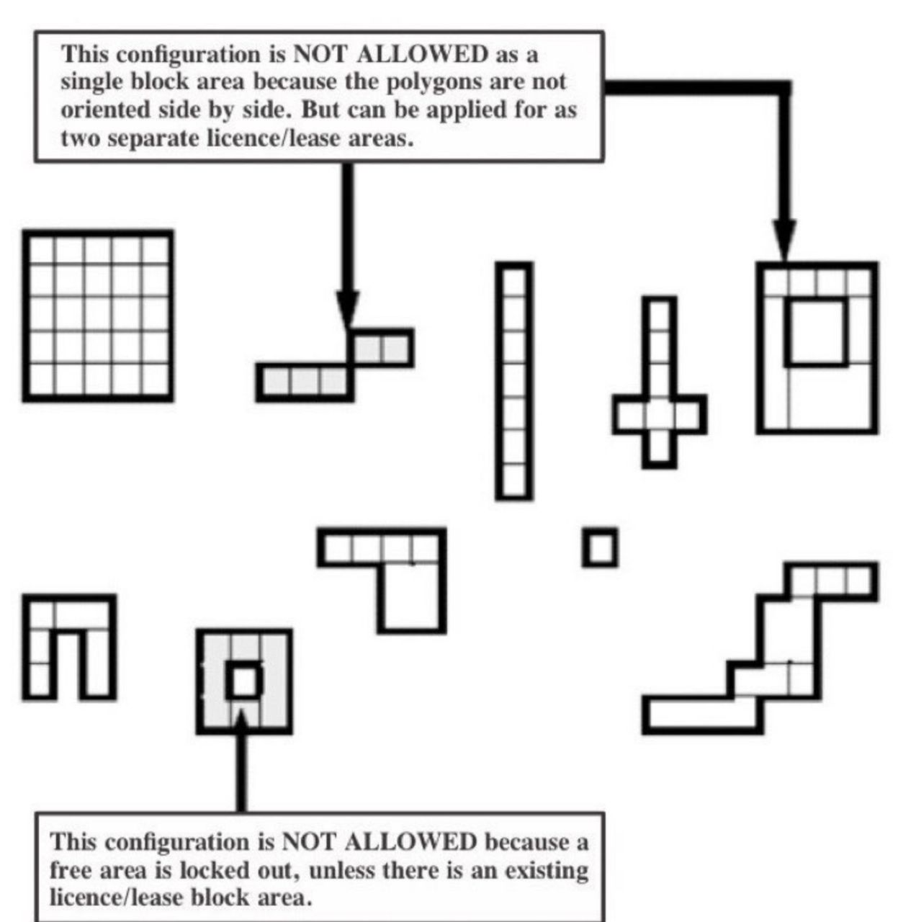

NIGERIA

MINING CADASTRE OFFIC E. 19-

5.0 LICENCE/PERMIT APPLICATION PROCEDURES

5.1 General Application Procedures

Application forms can be downloaded from the agency's website: www.miningcadastre.gov.ng.

The general procedures to be followed in making application to the MCO for a Mineral Title are as follows:

i. Submit duly completed application form online along with the necessary documents (as specified in the application guideline/form) and processing fees to the MCO in line with the provisions of the Act, and the Regulations. In addition, 3 hard copies of the application must be submitted at the MCO headquarters or any of the Nigeria Mining Cadastre Zonal Office nationwide.

ii. Submitted application shall be assigned with an identifying code and registered with date, hour and minute, corresponding to the online priority register duly signed. One hard copy of the submitted application shall be given to the applicant as acknowledgment of the receipt of the application.

iii. Upon the submission and receipt of an application for a Mineral Title, MCO shall notify landowner(s)/occupier(s) and obtain an irrevocable consent to be submitted back to MCO within fourteen (14) days from the date of receipt of the application by the applicant.



NIGERIA

MINING CADASTRE OFFIC E 20-

iv. Incomplete or wrongly completed application shall be rejected.

v. Payments made is non-refundable.

vi. Where application requires minor amendments (not coordinates), the applicant shall be duly informed to effect the necessary corrections within a period of 5 working days; and if no response is received from the applicant within the specified period, the application shall be rejected without any refund.

vii. A valid application received shall be further evaluated and recommended for Approval or Refusal as the case may be.

viii. If a Licence/Lease/Permit is granted, the applicant shall be notified via registered email and be given 2 weeks within which to pay the Annual Service Fee (see table fees), a pre-requisite among other obligations before collection of the Licence/Permit or Lease.

ix. If the applicant fails to pay the Annual Service Fees within fourteen (14) days after grant is sent electronically, the grant shall automatically be withdrawn.

5.1 Step by Step Procedures for mineral title applications based on eMC+ system (GAF version to be adopted but which need to be converted to editable format)

NIGERIA-

MINING CADASTRE OFFIC E 21-

**5.1 Step by Step Procedures for mineral title applications based on eMC+ system (GAF version to be adopted but which need to be converted to editable format)**

# **i. How to submit an application at MCO?**

**1.**

Download application forms

from the

cadastre website

https://nigeriaminingcadastre.gov.ng/emc

**2.**

Fill-in application forms and prepare all

necessary documents in triplicate

*9:00 - 12:30 and 13:30 - 16:00*

*9:00 - 12:30 and 13:30 - 15:00*

*Friday:*

*Friday:*



**6.**

Application evaluation and processing

by MCO

*(duration depends on type of application; usually between 30 and 45 days)*



**5.**

Submit application and wait to get your

registration receipt



**3.**

Pay application processing fee at your

bank

*(remember to keep the payment receipt)*



**4.**

Visit the MCO HQ in Abuja or the Zonal Office where the application is located

*Monday – Thursday:*

*Friday:*

*9:00 - 12:30 and 13:30 - 16:00*

*9:00 - 12:30 and 13:30 - 15:00*

**8.**

Collect mineral title documents

within 14 days



**7.**

Pay initial Annual Service Fee within 14

days

*(not required for all application types)*

**ii. How to submit an online application?**



**1.**

Register the company & create user

account on the cadastre website

https://nigeriaminingcadastre.gov.ng/emc

**2**.

Download application forms from the cadastre website

**3.**

Fill-in application forms and prepare all

necessary documents in triplicate

**4.**

Scan a single set of the signed application forms and all required documents

*(applicable formats: see below)*

**6.**

Fill-in the application details and upload all scanned application forms and documents



**5.**

Login to the cadastre website

https://nigeriaminingcadastre.gov.ng/emc

**8.**

Send the hard-copies of the application forms and documents in triplicate to MCO by courier

*37 Lobito Crescent; Off Ademola Adetokunbo, Wuse II, Abuja, Federal Republic of Nigeria*



**7.**

Pay application processing fee by credit card



**10.**

Pay initial Annual Service Fee within 14 days

*(not required for all application types)*



**9.**

Application evaluation, processing and grant

by MCO

*(Duration depends on type of application;*

*usually between 30 and 45 days)*

**12.**



**Allowed digital formats**

Format: **PDF/A**

Resolution: 200 dpi (text)

300 dpi (maps)

Format: **JPG, PNG** Resolution: Max. 300 dpi Bit-depth: 24bit (color)

4bit (black & white)

**11.**

Collect mineral title documents within 14 days

**iii. How can I check the status of my application?**



**1**

Login to the Cadastre website using your login details (username & password)

https://nigeriaminingcadastre.gov.ng/emc



**2.**

Open the transaction register and select

the corresponding application



**3.**

Check evaluation results and processing

status

**iv. How can I pay my Annual Service Fee online?**



**1.**

Login to the cadastre website

https://nigeriaminingcadastre.gov.ng/emc



**2.**

Open the register with the list of pending

payments



**3.**

Select the payment demand and pay the

Annual Service Fee by credit card

*(not required for all types of mineral titles)*

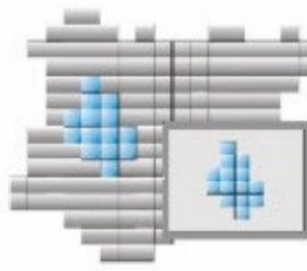

NIGERIA

MINING CADASTRE OFFICE

MINING CADACTDE OFEICE